porta

Ignition QC Process Control System
  - Complete project framework for plant-wide digital process-control forms
Prepared for: Myrtleford Plant
Prepared by: Nguyen Trieu, Automation and Control Engineer
Document status: Consolidated concept and implementation framework
Version: Draft 0.2
Date: 16 July 2026
PROJECT INTENT
Replace controlled paper and Excel process-control forms with authenticated, station-aware Ignition Perspective pages, a central SQL record, automated validation, managed non-conformance workflows, and QC/management visibility.

Executive summary
The project is a configurable electronic process-control platform, not a collection of one-off spreadsheet replicas. One reusable application framework will present the correct controlled form at each production station, apply the correct effective-dated specification, record authenticated entries, evaluate compliance, initiate the appropriate recheck or escalation workflow, and create a searchable audit trail. This consolidated revision (Draft 0.2) aligns the framework with the amended user model: two business roles - QC Technician and QC Manager - working in one Ignition Perspective project with two dedicated workspaces, staged cross-stage product tracking from Lathe to finished panel, and an expanded QC Manager analytical environment. Technical administration remains outside the application in Ignition Designer, Gateway and database tools.
DESIGN PRINCIPLE
Build one reusable inspection and workflow framework; configure many forms. Preserve the company visual language: grey section bands, light work surfaces, strong black text, Porta red branding, yellow action/warning controls, bright green positive controls, and purple reject/review controls.

Contents
1. Vision, scope and outcomes
2. Source form landscape and form families
3. User roles, workspaces and journeys
4. UX design system and company theme
5. QC Technician workspace and data-entry mockups
6. QC Manager dashboard mockup
7. Cross-stage tracking and product genealogy
8. Status, validation and pulsing animation
9. Functional architecture
10. Data architecture and audit model
11. Form, specification and schedule configuration
12. Non-conformance workflow
13. Ignition Perspective implementation pattern
14. Security, authentication and electronic identity
15. Reporting, dashboards and manager analytics
16. Integration, availability and recovery
17. Testing and acceptance
18. Delivery roadmap and governance
19. Deliverables and exportable package
Appendix A. Example CSS and binding logic
Appendix B. Page and component catalogue
Appendix C. Initial risk register

1. Vision, scope and outcomes

1.1 Vision
Develop a plant-wide Ignition Perspective application that digitises process-control sheets, tracking logs, setup records, time sheets and QC checks. Operators use a tablet or PC at each station; QC and management use central exception, HOLD, compliance and trend views.

1.2 Scope
In scope | Description
Digital data entry | Responsive station pages, current-shift logs, draft/save/submit and controlled correction.
Rules and specifications | Effective-dated minimum, target and maximum values selected by product, grade, thickness, variant, station and form revision.
Scheduling | Hourly, two-hourly, per-load, per-pack, per-event, shift-start and post-failure increased-frequency checks.
Workflow | Rechecks, comments, role notifications, HOLD, stop-process, maintenance involvement, verification and QC closure.
Records | SQL inspection headers, individual measurements, applied specification snapshot, audit events and exception history.
Insights | Live exception queue, compliance, overdue checks, HOLD register, calibration, trends and exports.
Cross-stage tracking | Correlation and genealogy search across connected production stages from Lathe Outfeed to finished panel, using a shared production tracking reference.

1.3 Success measures
No paper form required at a commissioned pilot station.
Every submitted result is linked to user, station, shift, product/pack or load, timestamp, form revision and applied specification.
Out-of-specification results are identified immediately and the required workflow cannot be skipped.
Submitted records cannot be silently overwritten; corrections are reasoned and auditable.
QC can find records and open exceptions without searching paper archives.
A second and third form can be commissioned primarily through configuration and reusable components.
A finished-panel issue can be traced to related upstream records through a shared production tracking reference.

2. Source form landscape and reusable form families
The current inventory includes approximately fifteen source documents spanning Lathe, Dryer, Composer, Core Stacker, Trim Saws, Saw Doctor, Layup, Peeler, Steamer and Sanding areas. The Form Register workbook remains the controlled discovery backlog.
Family | Typical forms | Reusable pattern
Dimensional / physical | Lathe Outfeed, Dryer Outfeed, Composer Outfeed, Sanding, Trim Saws | Grouped numeric measurements; positions; specification resolver; pass/fail and rechecks.
Repeated load / batch | Dryer Infeed, Composer Infeed, Core Stacker | Parent shift/production record with repeated child entries.
Time / duration | Layup Outfeed, Steamer Cart | Start/finish events, calculated duration, delay reason and notification.
Tooling / setup | Knife Setup, Knife Grinding | Equipment/tool ID, setup dimensions, approval, condition and lifecycle evidence.
Attribute inspection | Stamp, sand quality, T&G, tight scribe | Yes/No, Pass/Fail or controlled selection; comments/evidence on failure.
Scheduled compliance | Hourly, two-hourly, shift-start, post-failure | Due-soon/due/overdue scheduler and increased-frequency logic.

2.1 Process-stage grouping for navigation
The technician should not search through a flat folder of fifteen forms. Process forms are grouped by production stage, which keeps navigation intuitive and creates the structural foundation for cross-stage tracking.
Stage group | Typical forms | Cross-stage tracking relevance
Veneer Preparation | Lathe Outfeed, Dryer Infeed, Dryer Outfeed, Peeler Core Temperature | Green and dry veneer thickness and moisture baselines used for downstream comparison.
Veneer Assembly | Composer Infeed, Composer Outfeed, Core Stacker | Joint thickness and bond quality interpreted against upstream veneer condition.
Layup and Press Preparation | Layup Line / Extruder, Layup Outfeed, Steamer Cart | Glue spread, viscosity and transfer-time behaviour linked to bonding outcomes.
Finishing | Trim Saws, Formply Trim Saws, Sanding Line | Finished panel dimensions and final quality outcomes.
Tooling | Knife Setup, Knife Grinding | Equipment condition evidence linked to surface and dimensional results.

SOURCE CONTROL
The Excel/PDF layout is evidence of current requirements, not the target screen design. Every form revision, characteristic and action rule must be confirmed with the business owner before production release.

3. User roles, workspaces and journeys
The amended user model reduces the application to two business roles within one Ignition Perspective project, replacing the earlier five-role model. Both roles share the same database, authentication, header, theme, inspection components, specification engine, validation engine, audit system, process history and exception records.
Role | Primary permissions and experience
QC Technician | Primary data-entry and process-monitoring user: open process-control forms, enter measurements, save drafts and undo unsaved changes, submit completed checks, complete rechecks, record comments and corrective actions, identify affected packs/loads/carts, create or update QC exceptions, apply a HOLD when authorised, review due/overdue checks and search process-control records.
QC Manager | Receives everything available to the QC Technician, plus plant-wide overview, exception management, HOLD management and disposition, specification and form-rule management, historical analysis, graphs and charts, cross-stage product tracking, compliance reporting, trend analysis, controlled exports, audit review and configuration approval.
Technical administration (outside the application) | Technical configuration remains in Ignition Designer, Ignition Gateway, database management tools and controlled configuration tables, performed by the project developer or automation engineer. A dedicated in-application administrator interface is deferred to future work.

3.1 QC Technician journey
Sign in or resume authenticated session.
Station home shows current context and due work.
Start the due check; verify product, pack/load and measuring equipment.
Enter only values not available automatically.
Receive immediate field and process validation.
Save draft or submit.
See the new record at the top of the current-shift log.
If failed, follow the displayed recheck/escalation/HOLD workflow.

3.2 QC Manager journey
Open dashboard to see overdue checks, open exceptions, HOLD and calibration risk.
Prioritise the exception queue by severity and age.
Open an exception to see measurements, applied limits, rechecks, notifications and audit trail.
Assign or acknowledge work; record disposition and closure.
Review compliance and recurring failure trends by area, station, product and characteristic.

3.3 One project, two workspaces
The application is organised as two workspaces inside a single Ignition Perspective project. Each user signs in through the same authentication system and is assigned the QC_Technician or QC_Manager role; the QC Manager inherits all QC Technician functions and does not need a separate account to enter or review a process-control form.
Workspace | Contents
QC Technician workspace | Home (due checks, open rechecks, active exceptions, HOLD records, recently submitted records), Process Forms grouped by production stage, Current Check, Rechecks, Current Shift Log, Exceptions, HOLD Records and Record Search.
QC Manager workspace | Overview, Live QC Operations, Exceptions, HOLD Register, Cross-Stage Tracking, Process Trends, Product Quality, Compliance, Exception Analytics, HOLD Analytics, Reports and Controlled Configuration.
Shared foundation | One Ignition Perspective project and one database: same authentication, header, theme, inspection components, specification engine, validation engine, audit system, process history and exception records. No separate projects per role.

3.4 Simplified access matrix
Function area | QC Technician / QC Manager
Enter data, save drafts, undo, submit, complete rechecks | Yes / Yes
View recent station records; search historical records | Yes / Yes
Create and update QC exceptions | Yes / Yes
Create HOLD record | Yes, subject to QC rules / Yes
Record disposition and release HOLD | Limited or no / Yes
View due and overdue checks | Yes / Yes
Plant-wide compliance, graphs and analytics | Limited operational graphs / Full
Cross-stage tracking | View relevant record / Full
Export reports | Limited / Yes
Manage specifications; approve specification revisions | No / Yes
Manage form configuration | No / Yes, controlled
Technical Gateway administration | No / Outside the application

3.5 Workspace switching
A QC Manager moves between QC Operations and Manager Analytics workspaces from the same session. The default landing page for a QC Technician is the Technician Home (checks due now, due soon, overdue, current drafts, open rechecks, active exceptions, packs on HOLD and recently submitted records); the default landing page for a QC Manager is the Manager Overview.

4. UX design system and company theme
The supplied company screen uses a white/light-grey application surface, Porta red wordmark, grey section bars and alternating striping. Yellow buttons identify non-structural or attention selections, bright green identifies pallet/positive selection, and light purple identifies reject/review actions. The new QC project should follow the pattern while improving hierarchy, accessibility and state clarity.
Token | Recommended use | Colour
Porta red | Brand, page title accent, critical emphasis | D7194B
Dark charcoal | Primary text and table header | 343A40
Light grey | Page background and disabled/read-only context | F3F3F3
Mid grey | Section bands and alternating process rows | A6A6A6
Yellow | Warning, action required, recheck | FFF200
Bright green | Pass, current, success, positive action | 00E62E
Light purple | Reject, QC review, disposition or HOLD-related control | 9999FF
Red | Failed measurement and critical exception | E53935

4.1 Core interaction rules
Keep station, shift, user, product, pack/load, revision and connection status visible.
Use large touch targets; make primary controls approximately 48-56 px high.
Show units and the applicable limits next to every numerical input.
Use physical positions such as RHS/MID/LHS instead of ambiguous numbering where possible.
Derive target/specification from product and configuration; do not let an operator select an unrelated tolerance.
Use colour plus status text, icon and explanation; colour alone is insufficient.
Keep current work primary; show only concise recent history beside it.
Do not clear the entry page until the database confirms submission.

5. QC Technician workspace and data-entry mockups

5.1 Technician home mockup
The Technician Home is the default landing page for the QC Technician role. It answers three questions at a glance: what is due now, what QC actions are still open, and what has just been submitted. The mockup follows the same grey-band and bright action-colour pattern as the data-entry page.
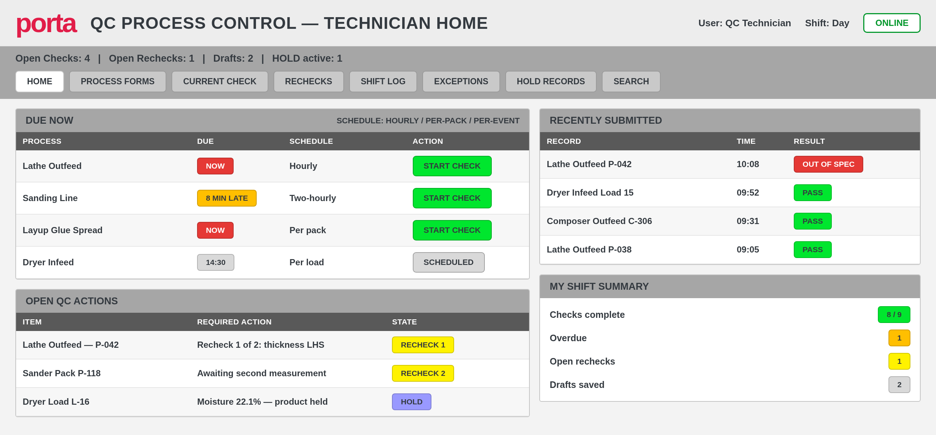
Figure 1. Proposed QC Technician home page - concept only.
Due-now list with schedule type and a prominent start action for each check.
Open QC actions covering rechecks, second measurements and active HOLD records.
Recently submitted records lead with status so failures are visible without scrolling.
A personal shift summary keeps completion, overdue, recheck and draft counts visible.

5.2 Data-entry mockup
The proposed large-screen layout retains the requested side-by-side pattern: current inspection on the left and the current-shift log on the right. The mockup follows the company grey-band and bright action-colour pattern while adding limits, explicit status, workflow guidance and shift compliance.
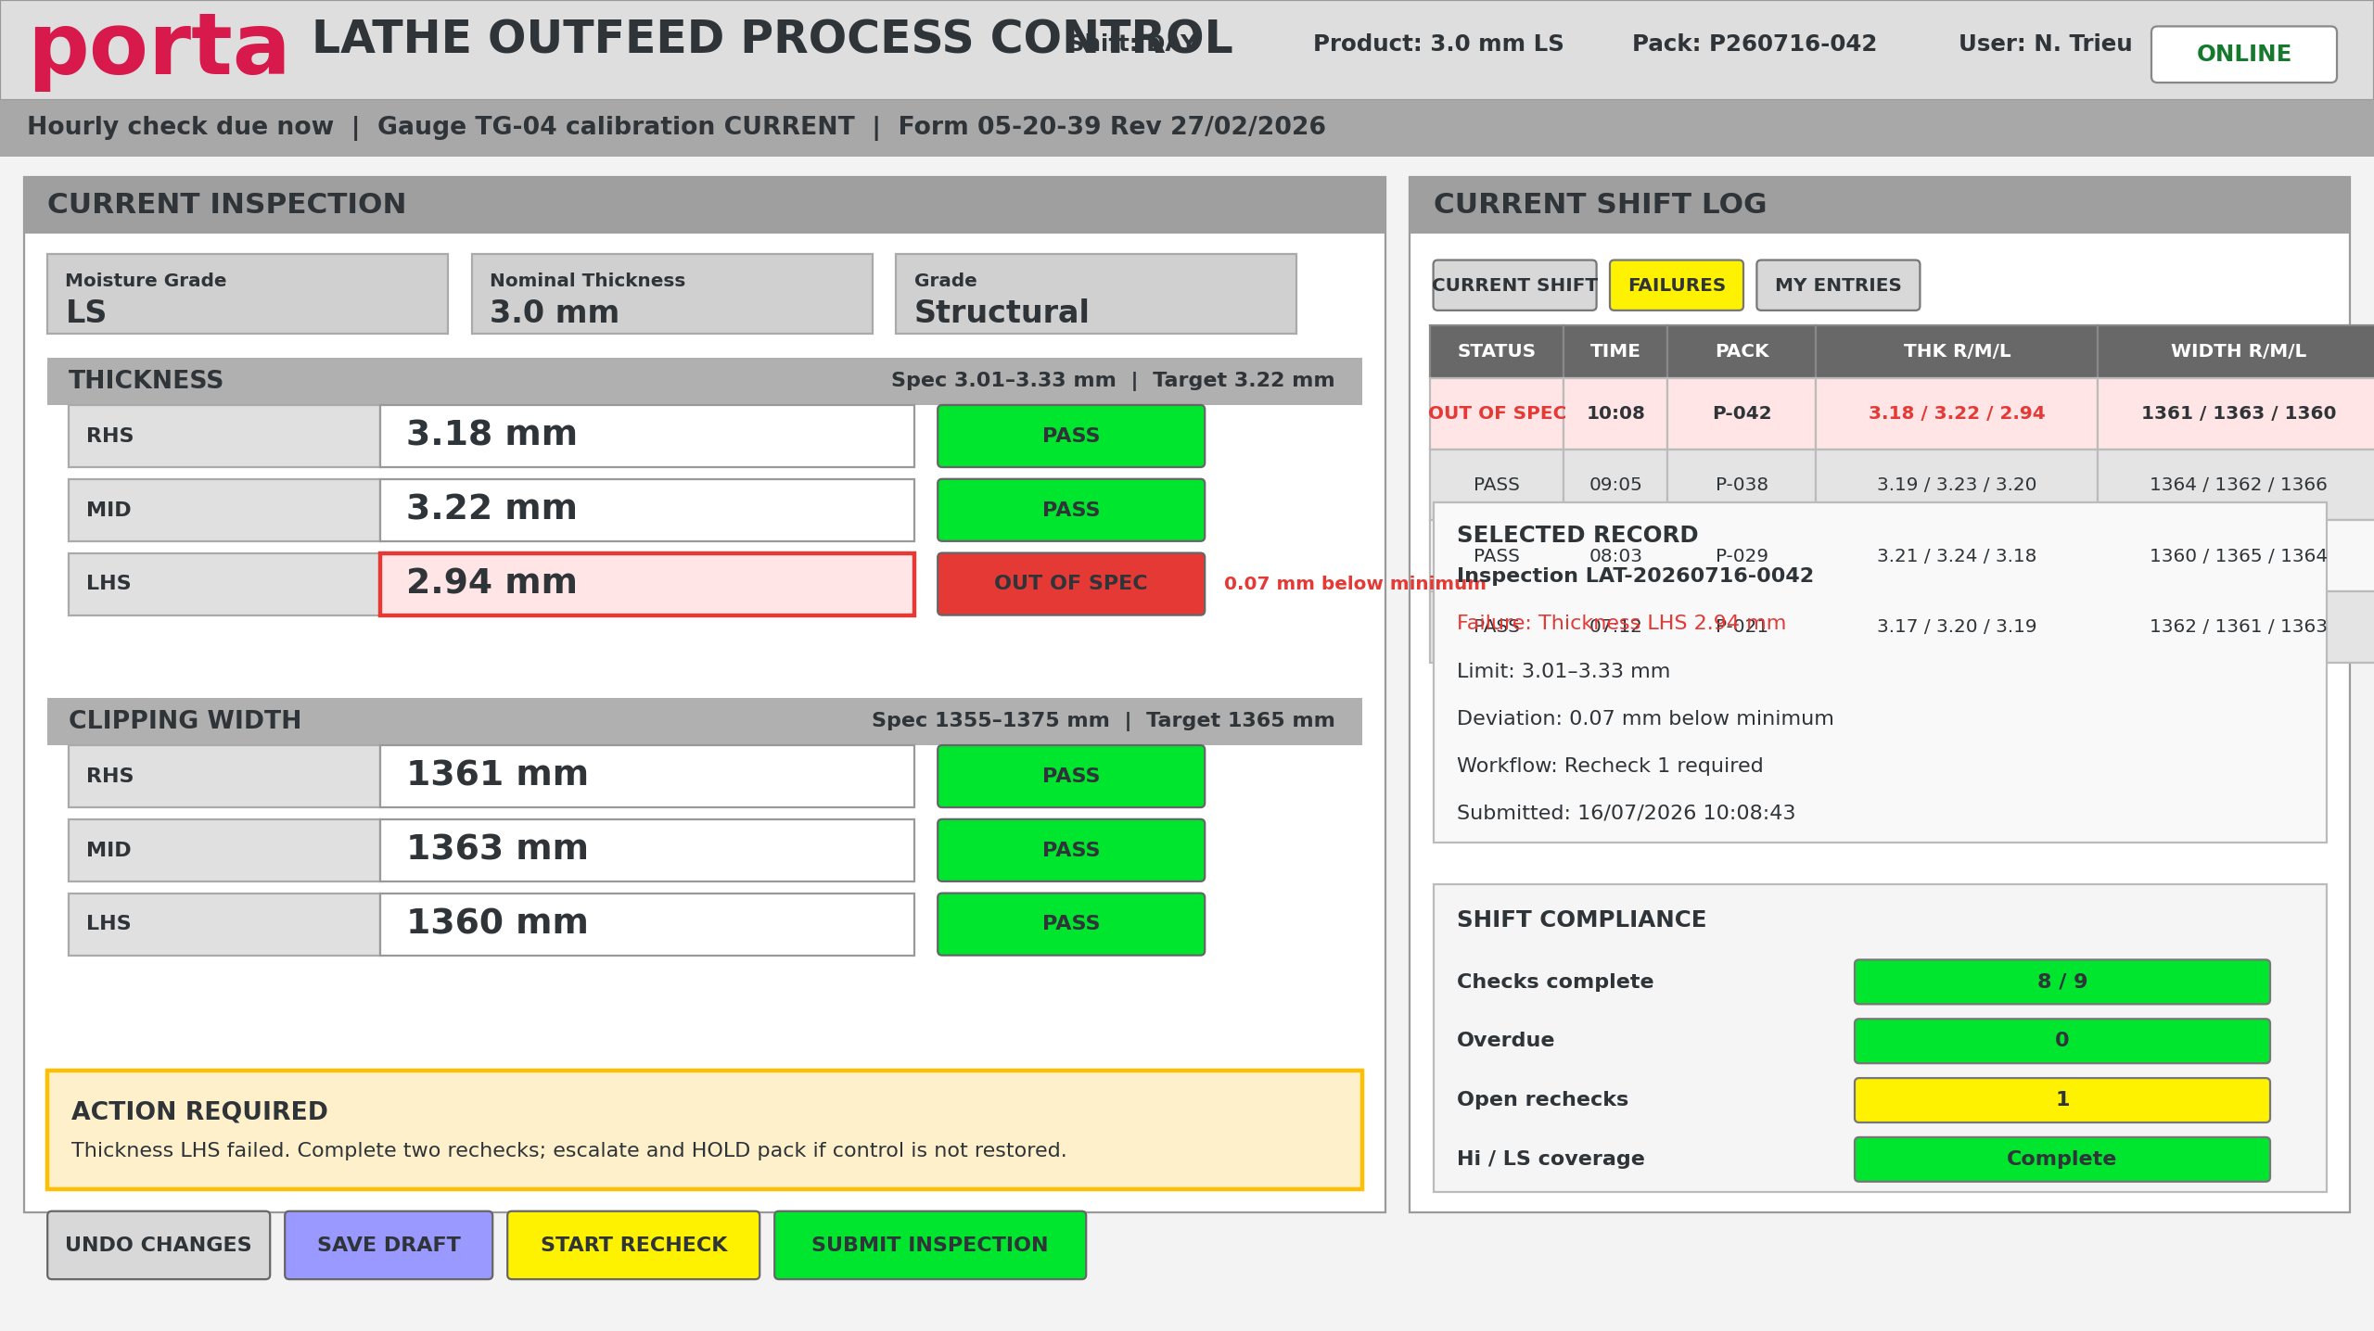
Figure 2. Proposed Lathe Outfeed operator page - concept only.

5.3 Layout behaviour
Desktop/large landscape tablet: 55-65% entry panel and 35-45% recent log.
Portrait tablet: entry form first, followed by three to five recent records.
The latest submitted record appears at the top and receives a brief confirmation highlight.
The current-shift log leads with Status and avoids primary horizontal scrolling.
Selecting a history row opens full inspection detail and audit information.
The action area shows the next required step rather than leaving the operator with only a red field.

6. QC Manager dashboard mockup
The manager experience is exception-led. Summary cards show workload and risk; the live queue prioritises action; compliance and trend panels explain recurring issues; the process matrix exposes station-level status.
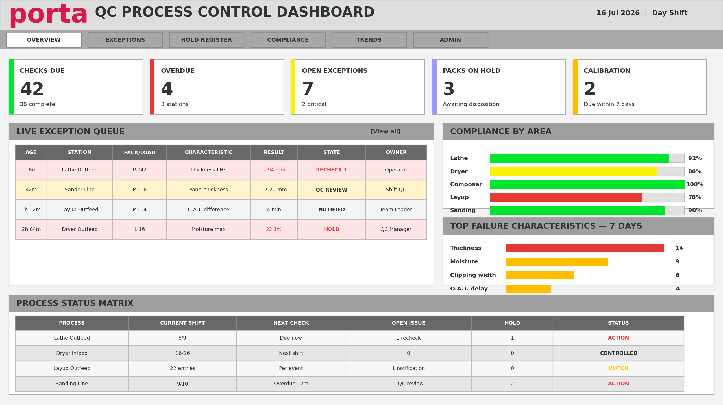
Figure 3. Proposed QC Manager overview dashboard - concept only.

6.1 Core manager views
View | Purpose
Overview | KPI cards (checks due and completed, on-time and first-pass compliance, overdue checks, open and critical exceptions, packs on HOLD, average exception age, calibration issues) plus the process status matrix.
Live operations | Current-shift activity, due and overdue checks and station-level status across all production stages.
Exception queue | Severity, age, process stage, station, product, pack/load/batch, failed characteristic, actual result, specification, workflow state, assigned QC technician and HOLD state.
Exception detail | Complete inspection, limit snapshot, rechecks, notifications, comments, evidence, disposition and audit timeline.
HOLD register | Affected product, issue, quantity/packs, location, owner, disposition and release authority.
Cross-stage tracking | Follow one production unit across connected stages from Lathe to finished panel; see section 7.
Process trends | Measurements plotted against the applied specification snapshot with pass/warning/fail markers, shift boundaries, product changes, adjustment and recheck annotations.
Product quality | Per-product checks completed, first-pass compliance, most frequent failures and cross-stage observations.
Compliance | Required versus completed checks by process, form, shift, day/week/month, technician and product.
Exception and HOLD analytics | Ageing, acknowledgement and disposition times, recheck success rates, escalation, HOLD and repeat-failure rates.
Reports | Controlled exports and agreed scheduled reports.
Controlled configuration | Specifications, form revisions, check frequencies, warning bands and non-conformance instructions; see section 11.4.

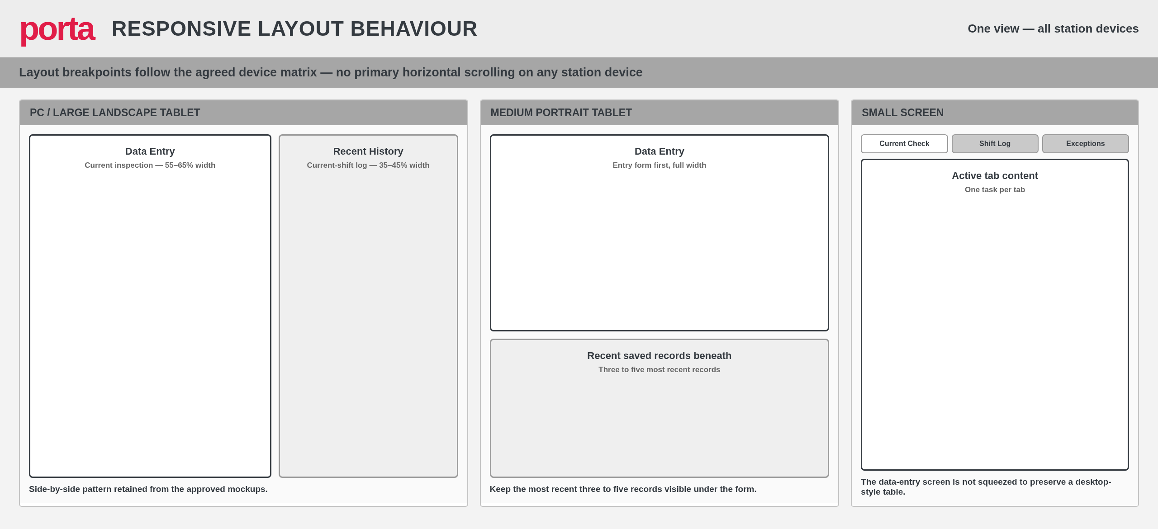
Figure 4. Responsive layout behaviour for PC, portrait tablet and small screens - concept only.

7. Cross-stage tracking and product genealogy
The controlled forms cover connected production operations rather than isolated checks. Cross-stage tracking lets the QC Manager follow the same material, pack, load, batch or production order from green veneer to finished panel, and turns individual checks into a continuous quality story.

7.1 Why cross-stage tracking
A production unit progresses through Lathe, Dryer Infeed, Dryer Outfeed, Composer / Core Stacker, Layup, press-related processes, Trim Saws and Sanding before becoming a finished panel. When a finished panel has a thickness, moisture, bonding or dimensional problem, the primary question is what happened to the associated material at earlier stages:
Was green veneer thickness outside the preferred range at Lathe Outfeed?
Was actual veneer thickness unusual at Dryer Infeed, or moisture high at Dryer Outfeed?
Was Composer joint thickness or bond quality abnormal?
Was glue spread or viscosity outside its preferred range at Layup, or pre-press-to-cramp time excessive?
Did the same production unit later fail panel thickness at Sanding?
Was affected product placed on HOLD at any earlier stage?

7.2 Identifier strategy
Cross-stage tracking requires a common link between records. The recommended approach is a central Production Tracking ID stored on every inspection together with process stage, stage-specific pack/load/cart ID, parent tracking ID, product, grade, nominal thickness, station, production order and start/finish times.
Identifier option | Notes
Production Tracking ID (recommended) | One central reference recorded by every relevant inspection; simplest reliable link between stages.
Production order | Strong where consistently available from ERP/PLC; not yet present on all stations.
Pack / load / cart number | Already on the forms, but identity changes between stages.
Batch number or product run | Useful for correlation; too coarse for unit-level genealogy.
Shift and timestamp range | Fallback correlation only; never presented as a guaranteed link.
Barcode / QR code | Low-cost scanning route to capture the tracking ID at each station.
Parent and child pack relationships | Required to represent splits and combinations between stages.
Material identity changes between stages, so the data model must represent splits and combinations - for example Lathe Pack LP-042 becoming Dryer Load DL-118, then Composer Packs CP-301 and CP-302, combining into Layup Pack LU-094 and finishing as Packs FP-441 and FP-442. This is a basic, deliberate form of product genealogy.

7.3 Staged implementation
A complete automated genealogy system could become another large project and must not delay the digital-form pilot. Implementation is therefore staged:
Level | Scope and outcome
Level 1 - Correlate | Search and compare across processes using date, shift, product, grade, nominal thickness, pack/load number, station, sample time and production order where available. Produces correlation, not guaranteed genealogy.
Level 2 - Tracking ID | A common manually entered or scanned Production Tracking ID recorded on every relevant inspection. Reliable links without full ERP/PLC integration.
Level 3 - Automated genealogy | PLC product tracking, production orders, pack labels, barcode scanning, ERP/production database and split/merge genealogy. Future work.
RECOMMENDED SCOPE
Include Level 1 and database readiness for Level 2 in the initial architecture. Implement Level 2 when a suitable pack, batch or production identifier has been agreed. Do not make full automatic Level 3 genealogy a prerequisite for digitising the first forms.

7.4 Cross-stage tracking page mockup
The tracking page searches by tracking ID, production order, pack/load, product or date range, then presents the unit as a stage timeline. Each stage card summarises its inspection outcome; selecting a stage opens the complete inspection record with measurements, applied specifications, comments, rechecks, exceptions, HOLD actions and audit trail.
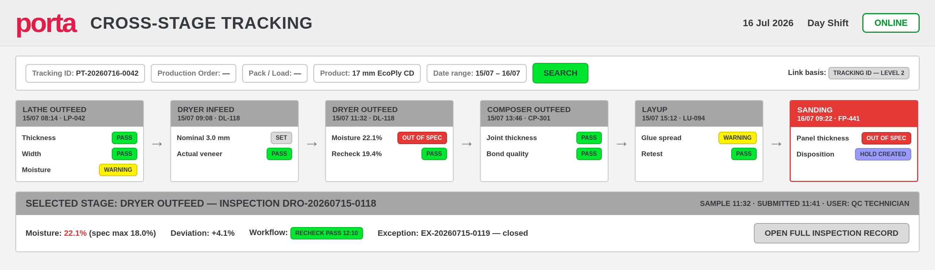
Figure 5. Proposed cross-stage tracking page with stage timeline - concept only.
Stage cards show the stage-specific pack/load identity, sample time and characteristic outcomes with the standard status palette.
Failed or held stages are visually emphasised; rechecks and their outcomes remain visible on the same card.
The selected-stage panel shows the applied specification snapshot, deviation, workflow outcome and a direct link to the full inspection record.

7.5 Cross-stage comparison and correlation
The QC Manager can compare related characteristics across stages, for example green veneer thickness at the Lathe against dry veneer thickness, Composer joint thickness and finished panel thickness. Because these characteristics use different numeric scales, two display modes are provided: an actual-value view in original units, and a normalised deviation view - (Actual - Target) or (Actual - Target) / specification tolerance - where a value near zero is on target.
Every comparative analysis shows the number of linked and unlinked records, the date range, the product population, excluded records, and whether the relationship is a direct genealogy link or only a date/product correlation. Typical analyses include Lathe thickness versus finished panel thickness, Dryer moisture versus bond-quality result, glue spread versus bond-quality failure, and Layup transfer time versus downstream quality.
CORRELATION IS NOT GENEALOGY
Associations found through Level 1 correlation must be described as associations unless a direct material link exists. The system must not imply that an upstream record caused a downstream result when the linkage is only date, product and shift proximity.

8. Status, validation and pulsing animation

8.1 Status model
State | Presentation | Behaviour
Not entered | Neutral grey | No result yet.
Unsaved / draft | Blue or purple status | Value exists but does not count as a completed check.
Pass | Green badge/border plus PASS | Within specification.
Warning | Yellow/amber plus WARNING and reason | Near limit, due soon, calibration approaching expiry or other agreed warning rule.
Out of spec | Red border/fill plus OUT OF SPEC and deviation | Creates required recheck/exception workflow.
QC review | Purple plus QC REVIEW | Measurement recorded; authorised disposition pending.
HOLD | Purple/red plus HOLD | Affected product blocked until disposition/release.

8.2 Animation rule
Use animation only when a result first changes into Warning or Failed. Pulse the field and/or status badge for approximately 2-4 seconds, then retain a solid warning/fail style. Never rely on perpetual flashing as the only alarm, and avoid animating an entire table. Respect reduced-motion preferences.
RECOMMENDED
A failed value receives a short three-cycle pulse, a persistent red border and pale-red fill, an OUT OF SPEC label, a deviation message, and a visible next-action panel. A warning uses amber/yellow in the same pattern.

8.3 Perspective implementation options
Built-in animated Style Class: define key stops and bind the component style class to the validation state.
Advanced Stylesheet (Ignition 8.1.22+): define project-scoped keyframes and apply a psc- prefixed Style Class.
Event flag: set a transient pulse flag when a value transitions to warning/fail; clear the flag after the animation period while leaving the persistent status class active.
Table rows/cells: use row/cell style rules for persistent highlighting; animate only the newly created or newly failed item.

9. Functional architecture
The architecture separates station experience, shared business logic, data persistence and management insight. Form screens should not contain duplicated specification or workflow logic.
Layer | Responsibilities
Station context | Configured station/device, user, shift, product, order, pack/load/cart and machine state.
Form renderer | Loads form revision, sections, characteristics, controls, visibility and display order.
Specification resolver | Selects the one approved effective specification and returns minimum/target/maximum/unit.
Validation engine | Validates data type, plausibility, required fields, specification result and form-level rules.
Scheduler | Creates/checks due work and manages due-soon, overdue and increased-frequency states.
Workflow engine | Rechecks, notifications, HOLD, stop-process, maintenance, verification and closure.
Persistence service | Transactional saves, idempotency, specification snapshot and audit events.
Reporting layer | Current-shift logs, queues, dashboards, trends and controlled exports.
Workspace shell | Role-based QC Technician and QC Manager workspaces in one project, sharing navigation, header context, theme and services.
Cross-stage tracking service | Resolves production tracking IDs, parent-child links and stage timelines; reports link quality (genealogy versus correlation).

10. Data architecture and audit model
Entity | Purpose
qc_form_definition | Controlled form identity, title, reference, owner and process.
qc_form_revision | Effective-dated approved revision and lifecycle state.
qc_section_definition | Logical screen sections.
qc_characteristic_definition | Field/data type, unit, precision, positions, display order and rules.
qc_specification | Product/grade/variant/station dependent limits and approval.
qc_schedule_rule | Frequency, first-check offset, grace, applicability and post-failure frequency.
qc_inspection | Inspection header: context, user, times and overall state.
qc_measurement | Individual entered/calculated value and applied-limit snapshot.
qc_nonconformance | Failure, severity, workflow, HOLD and closure.
qc_workflow_event | Recheck, notification, acknowledgement, action, disposition and verification.
qc_audit_event | Old/new value, action, reason, user, timestamp and source.
equipment_calibration | Instrument identity, due date, status and evidence.
qc_tracking_unit | Production Tracking ID, process stage, stage-specific pack/load/cart ID, product, grade, nominal thickness, station, production order and start/finish times.
qc_tracking_link | Parent-child relationships between tracking units representing splits and combinations, with link type (scanned/entered genealogy versus inferred correlation).

10.1 Non-negotiable record rules
Store the specification values applied at submission; historical pass/fail must not change when a future specification changes.
Use database-generated inspection IDs and an idempotency key to prevent duplicate saves.
Save inspection header, measurements, exception creation and audit event in one transaction.
Submitted results are immutable to ordinary users; corrections create a controlled amendment.
Record sample time separately from submitted time and corrected time.
Use soft retirement/effective dating for configuration; do not delete historical definitions referenced by records.

11. Form, specification and schedule configuration

11.1 Form definition
Form reference, title, revision, issue/effective dates and owner.
Applicable process, station and role.
Sections and field display order.
Input component type, unit, precision and required state.
Calculation rule, visibility rule and failure message.

11.2 Specification resolution
Resolve the most specific approved specification matching the active date, form revision, characteristic, product, grade, nominal thickness, variant/veneer type and station. If zero or multiple equally valid rules are found, block submission and raise a configuration exception rather than guessing.

11.3 Schedule types
Type | Example
Shift start | First hourly check within 30 minutes of shift start.
Interval | Hourly or two-hourly.
Per event | Every pack/load/cart or process event.
Coverage | At least one Hi and one LS pack per shift.
Product change | Check when product/grade/nominal changes.
Post-failure | Every 30 minutes until control is restored.
Post-adjustment | Verify first pack after repair or adjustment.

11.4 Controlled configuration lifecycle for the QC Manager
The QC Manager workspace contains only essential business configuration: specifications, form revisions, check frequencies, warning bands and non-conformance instructions. Configuration follows a simple controlled lifecycle:
DRAFT -> ACTIVE -> SUPERSEDED. The QC Manager creates or edits a draft, activates the approved version, and the previous active version becomes superseded. Existing historical records remain linked to their original revision, and the effective date and user are recorded for every change.
Technical items remain outside the manager interface: database connection, Gateway settings, Identity Provider, PLC tag configuration, project resource changes, script editing and security-role configuration. This keeps in-application administration focused on Quality rather than system engineering.

12. Non-conformance workflow
Workflow steps are configurable by form and characteristic; Lathe, Layup and Sanding do not share identical action plans.
1. Failure detected and immutable failed measurement recorded.
2. Display deviation and immediate operator instruction.
3. Require reason/comment where applicable.
4. Create Recheck 1 and Recheck 2 according to the controlled action plan.
5. If control is restored, retain the full history and final outcome.
6. If not restored, notify configured roles and create an exception.
7. Apply HOLD/stop-process/maintenance actions when configured.
8. Capture affected packs/loads and first-off verification.
9. QC records disposition and authorised release/closure.

12.1 Exception state model
OPEN -> RECHECK REQUIRED -> ESCALATED -> HOLD / ACTION IN PROGRESS -> VERIFICATION REQUIRED -> QC REVIEW -> CLOSED, with CANCELLED only for an authorised duplicate/invalid workflow and never as a method of erasing evidence.

13. Ignition Perspective implementation pattern

13.1 Page structure
/tech/home
/tech/forms (grouped by production stage)
/tech/inspection/:inspectionId
/tech/rechecks
/tech/shift-log
/tech/exceptions
/tech/exception/:exceptionId
/tech/hold-records
/tech/search
/manager/overview
/manager/live-operations
/manager/exceptions
/manager/hold-register
/manager/cross-stage-tracking
/manager/trends
/manager/product-quality
/manager/compliance
/manager/exception-analytics
/manager/hold-analytics
/manager/reports
/manager/configuration

13.2 Shared views/components
shared/HeaderContext
shared/DueCheckBanner
shared/ProductionContext
shared/CalibrationPanel
shared/MeasurementGroup
shared/NumericMeasurement
shared/AttributeMeasurement
shared/TimeMeasurement
shared/StatusBadge
shared/ActionRequiredPanel
shared/CurrentShiftLog
shared/SaveSubmitBar
shared/AuditTimeline
shared/KpiCard
shared/ProcessStatusMatrix
shared/TrackingSearchPanel
shared/StageTimeline
shared/CrossStageComparisonChart
shared/LinkQualityIndicator

13.3 Named-query groups
Configuration: active form, revision, sections, characteristics, specification and schedule.
Inspection: create draft, load draft, transactional submit, current shift history and detail.
Workflow: create exception, add recheck, notify/acknowledge, HOLD, disposition and close.
Reporting: compliance, overdue, trend series, exception queue and calibration risk.

13.4 Scripting principles
Place shared logic in project library scripts, not individual component event scripts.
Use parameterised named queries for database access.
Define one status evaluation contract used by input components, history tables and dashboards.
Use structured logging with inspection ID, station and user context.
Handle database failure explicitly and never show a success state until commit confirmation.

14. Security, authentication and electronic identity
Use an approved Ignition Identity Provider with the QC_Technician and QC_Manager security levels; the QC Manager role inherits all QC Technician functions.
Display signed-in identity continuously and require practical user changeover on shared station devices.
Use role-based access for correction, specification approval, HOLD disposition/release and form configuration; workspace visibility follows the simplified access matrix in section 3.4.
Record authentication identity rather than typed initials as the primary electronic attribution.
Use idle timeout appropriate to the station, with safe handling of unsaved drafts.
Authorise every named query and sensitive page server-side; hiding a component is not sufficient security.
Log specification approval, correction, disposition and release as high-value audit events.
SEPARATION OF DUTIES
Where quality governance requires it, the person entering a result should not be the only person permitted to approve a specification change, release HOLD product or close a critical exception.

15. Reporting, dashboards and manager analytics
Metric / view | Definition
On-time completion | Completed required checks / due checks within agreed grace.
First-pass compliance | Inspections passing without recheck / submitted inspections.
Open exception age | Time since failure or escalation, by severity and owner.
HOLD ageing | Time from HOLD creation to disposition/release.
Recheck success | Failures restored within configured rechecks.
Failure Pareto | Count/rate by process, station, product, characteristic and shift.
Specification trend | Actual values plotted against the applied min/target/max snapshot.
Calibration risk | Expired and due-soon instruments used by inspection process.
Data quality | Drafts abandoned, missing context, corrections and duplicated attempts.

SPC and capability metrics should be introduced after data definitions, sampling assumptions and measurement systems are validated. A dashboard should not imply statistical control solely because values are displayed over time.

15.1 Manager analytics catalogue
The QC Manager workspace is a substantial analytical environment, not just a larger process log. The following analytical views are provided in addition to the operational metrics above:
Analytics view | Content
Process trends | Measurement over time against minimum/target/maximum bands, pass/warning/fail markers, shift boundaries, product-change, adjustment, maintenance and recheck annotations; filtered by date range, process, station, product, grade, nominal thickness, characteristic and shift.
Cross-stage correlation | Related characteristics compared across stages (for example Lathe thickness versus finished panel thickness, Dryer moisture versus bond quality), always showing linked/unlinked record counts and whether the link is genealogy or correlation.
Failure Pareto | Failure count, percentage and cumulative percentage by characteristic, process stage, product, shift and station.
Compliance reporting | Required, completed, on-time, overdue and missed checks, rechecks completed, open drafts and calibration-warning checks by process, form, shift, period, technician and product.
Exception analytics | Opened/closed exceptions, average age, acknowledgement and disposition times, recheck success rates, escalation rate, HOLD rate and repeat failure rate.
HOLD analytics | Held packs by process, HOLD ageing, reason categories, disposition outcomes, quantity affected, time to release, repeat HOLD by product and upstream stages associated with downstream HOLD.
Product quality profile | Per-product checks completed, first-pass compliance, open exceptions, packs held, most frequent failures and cross-stage observations described as associations unless genealogy exists.

15.2 Process trends mockup
Trend views plot each measurement against the specification snapshot applied at submission, so historical pass/fail colouring never changes when a future specification changes. The mockup shows one out-of-specification point with its recheck outcome annotated.
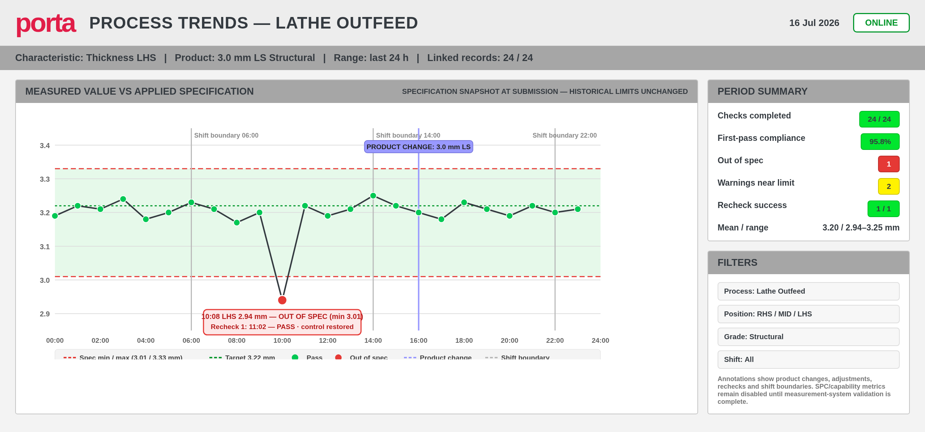
Figure 6. Proposed process trends view with applied specification snapshot - concept only.

16. Integration, availability and recovery

16.1 Integration priorities
PLC/machine tags: active product, recipe, states and timestamps where reliable.
Production/ERP: order, product, grade, nominal, pack/load and genealogy identifiers.
Barcode/QR: pack, load, cart, tool and gauge identification.
Calibration source: equipment status and due date.
Notifications: approved channels for QC, team leader, supervisor and maintenance.

16.2 Connection-loss behaviour
Always show gateway/database connectivity state.
Define whether drafts can be kept locally or must remain gateway-backed.
Never claim submission success without committed database confirmation.
Use an idempotency token so a retry cannot create a duplicate inspection.
If offline entry is allowed, label it OFFLINE PENDING and prevent dependent workflows until synchronised.
Document recovery, backup and restore objectives and test them before rollout.

16.3 First-release technical boundaries
The first release follows a deliberately simple, supportable architecture: Ignition Perspective views (session logic and bindings) call Named Queries and project-library scripts for business logic, which read and write the SQL Server database for inspections, drafts, exceptions, HOLD records, specifications, configuration, audit events, schedules and tracking references. PLC tags are used for live machine values and handshakes where already available, and Ignition reports, scheduled exports and notification profiles cover reporting and alerts.
Avoid in the first release: excessive client-side scripting that duplicates validation logic; direct PLC writes from QC screens without a defined handshake; ERP integration before the required production-order fields are agreed; automatic full product genealogy before tracking identifiers are standardised; and custom mobile applications before the browser-based experience is stable.

17. Testing and acceptance
Test class | Examples
Boundary values | Exactly minimum, exactly maximum, just below/above, decimal precision and unit conversion.
Specification selection | Every product/grade/variant combination; no match and duplicate match must fail safely.
Workflow | Pass, warning, first failure, recheck pass, repeated failure, HOLD, maintenance and closure.
Security | Operator versus QC/manager/admin access; direct URL and named-query enforcement.
Concurrency | Two sessions, duplicate tap, stale draft and simultaneous QC action.
Network | Latency, gateway disconnect, database unavailable and retry.
Usability | Gloves, mounted tablet, lighting, keyboard-only PC entry and full-shift repetition.
Record integrity | Audit old/new values, sample/submission times and immutable applied specification.
Performance | Agreed response thresholds under representative users and record volumes.
FAT/SAT | Controlled test scripts, expected result, evidence, defect and business sign-off.

17.1 Minimum UX acceptance
No primary horizontal scrolling on the agreed devices.
The next required action is visible after every failure.
A newly saved record is visible immediately with inspection ID and result.
The operator can distinguish unsaved, draft, submitted, pending and corrected states.
Every status uses text in addition to colour.
Touch controls and text remain usable at production stations.

18. Delivery roadmap and governance
Phase | Outcome
0. Discovery | Controlled form register, field inventory, specification matrix, schedule and workflow decisions.
1. Foundation and technician shell | Project, theme, navigation, authentication, Technician Home, global components, record and audit model, and the configuration schema for one form family.
2. Lathe Outfeed pilot | First process form as the reference implementation with specification snapshot, validation, recheck workflow, exception handling and audit.
3. Pilot hardening and manager workspace | Dryer Infeed and Dryer Outfeed forms added; QC Manager workspace with overview, live operations, exceptions, HOLD register, compliance and trend views.
4. Cross-stage tracking (Level 2) | Production Tracking ID agreed and recorded on each relevant inspection; tracking page, parent-child links and cross-stage comparison released.
5. Remaining-form migration | Composer, Layup, saws, sanding and tooling forms delivered through configuration and reuse; operational handover and continuous improvement.
Future | Automated genealogy (Level 3), ERP production-order integration, in-application administration and offline-capable station applications, each subject to a separate business case.

18.1 Governance
Business owner approves the digital interpretation of each controlled form.
Quality approves specification, action plan, audit and retention rules.
Automation owns reusable project code and technical standards.
IT owns infrastructure, backup, identity and cyber controls as agreed.
Each release has requirements traceability, FAT/SAT evidence and rollback plan.

19. Deliverables and exportable package
Ignition-QC-Framework/
01_Project_Definition/
02_Requirements/Form_Register.xlsx
03_Database/Schema.sql, Seed.sql, Data_Dictionary.xlsx
04_Ignition/Project_Export.zip, resources, scripts, named queries
05_UX/Wireframes, component catalogue, style guide
06_Testing/FAT.xlsx, SAT.xlsx, traceability.xlsx
07_Deployment/environment, backup, rollback, cutover
08_Training/operator and QC guides

The final importable Ignition package must be aligned to the installed Ignition version, modules, database engine, identity provider, environment names and project export format. The design framework is version-independent; the executable package is environment-specific.

19.1 Immediate next artefacts
Complete the Form Register for all source documents.
Confirm target Ignition version and database platform.
Define device/resolution matrix and station configuration.
Approve the UX theme, status palette and animation policy.
Create the logical/physical data model and first schema migration.
Build reusable NumericMeasurement, StatusBadge, CurrentShiftLog and ActionRequiredPanel components.
Implement Lathe Outfeed as the foundation pilot.
Agree the Production Tracking ID format and capture method with production and QC stakeholders.

Appendix A. Pulsing animation example
For Ignition 8.1.22 or later, enable the Advanced Stylesheet under Perspective > Styles. Perspective injects Style Classes with the .psc- prefix. The component should have a persistent state class and a temporary pulse class.
/* Persistent states */
.psc-qcFieldFail {
background: #ffe5e5;
border: 3px solid #e53935;
color: #222;
}
.psc-qcFieldWarning {
background: #fff7cc;
border: 3px solid #ffbf00;
color: #222;
}
/* Temporary attention pulse: three cycles, then stop */
.psc-qcPulseFail {
animation: qcPulseFail 0.75s ease-in-out 3;
}
.psc-qcPulseWarning {
animation: qcPulseWarning 0.75s ease-in-out 3;
}
@keyframes qcPulseFail {
0%, 100% { box-shadow: 0 0 0 0 rgba(229,57,53,0); transform: scale(1); }
50% { box-shadow: 0 0 0 6px rgba(229,57,53,.35); transform: scale(1.015); }
}
@keyframes qcPulseWarning {
0%, 100% { box-shadow: 0 0 0 0 rgba(255,191,0,0); transform: scale(1); }
50% { box-shadow: 0 0 0 6px rgba(255,191,0,.35); transform: scale(1.015); }
}
@media (prefers-reduced-motion: reduce) {
.psc-qcPulseFail, .psc-qcPulseWarning { animation: none; }
}

Binding pattern
# Expression binding concept for props.style.classes
# persistentStatusClass + optional transientPulseClass
if({view.custom.status} = 'FAIL',
'qcFieldFail' + if({view.custom.pulse}, ' qcPulseFail', ''),
if({view.custom.status} = 'WARNING',
'qcFieldWarning' + if({view.custom.pulse}, ' qcPulseWarning', ''),
'qcFieldNormal'
)
)

Set pulse true only when the state transitions into FAIL/WARNING. Clear the pulse flag after the animation interval, but keep status FAIL/WARNING so the persistent style remains. The exact event/timer method should match the chosen Perspective component and project scripting standard.

Recommended behaviour
Do not continuously blink every failed field.
Use this sequence:
- Measurement changes to WARNING or FAIL.
- Field pulses for three cycles.
- Animation stops automatically.
- Persistent yellow or red styling remains.
- Status text and deviation remain visible.
- The associated workflow remains open until resolved.
This gets the operator’s attention without creating continuous alarm fatigue.
Advanced Stylesheet example
Enable:
1 Perspective
2 └── Styles
3 └── Enable Advanced Stylesheet
Then add:
1 /* Normal persistent statuses */
2
3 .psc-qcFieldFail {
4 background: #ffe5e5;
5 border: 3px solid #e53935;
6 color: #222222;
7 }
8
9 .psc-qcFieldWarning {
10 background: #fff7cc;
11 border: 3px solid #ffbf00;
12 color: #222222;
13 }
14
15 .psc-qcFieldPass {
16 background: #efffee;
17 border: 2px solid #00b52a;
18 color: #222222;
19 }
20
21 /* Temporary attention animations */
22
23 .psc-qcPulseFail {
24 animation: qcPulseFail 0.75s ease-in-out 3;
25 }
26
27 .psc-qcPulseWarning {
28 animation: qcPulseWarning 0.75s ease-in-out 3;
29 }
30
31 @keyframes qcPulseFail {
32 0%,
33 100% {
34 box-shadow: 0 0 0 0 rgba(229, 57, 53, 0);
35 transform: scale(1);
36 }
37
38 50% {
39 box-shadow: 0 0 0 6px rgba(229, 57, 53, 0.35);
40 transform: scale(1.015);
41 }
42 }
43
44 @keyframes qcPulseWarning {
45 0%,
46 100% {
47 box-shadow: 0 0 0 0 rgba(255, 191, 0, 0);
48 transform: scale(1);
49 }
50
51 50% {
52 box-shadow: 0 0 0 6px rgba(255, 191, 0, 0.35);
53 transform: scale(1.015);
54 }
55 }
56
57 /* Accessibility and reduced-motion support */
58
59 @media (prefers-reduced-motion: reduce) {
60 .psc-qcPulseFail,
61 .psc-qcPulseWarning {
62 animation: none;
63 }
64 }
Ignition’s Advanced Stylesheet is project-scoped, meaning the animation can be exported with the Perspective project rather than being maintained as an external Gateway theme asset. ³ ⁴
Applying the classes
Use two kinds of classes:
Persistent class
Remains while the condition exists:
1 qcFieldFail
2 qcFieldWarning
3 qcFieldPass
Temporary animation class
Applied only when the status initially changes:
1 qcPulseFail
2 qcPulseWarning
Conceptual binding:
1 if status == "FAIL":
2 styleClass = "qcFieldFail"
3
4 if pulse:
5 styleClass += " qcPulseFail"
6
7 elif status == "WARNING":
8 styleClass = "qcFieldWarning"
9
10 if pulse:
11 styleClass += " qcPulseWarning"
12
13 elif status == "PASS":
14 styleClass = "qcFieldPass"
15
16 else:
17 styleClass = "qcFieldNormal"
Important implementation rule
The pulse flag must be separate from the status.
For example:
1 status = FAIL
2 pulse = true
After approximately three seconds:
1 status = FAIL
2 pulse = false
The result remains solid red, but the animation stops.
If the operator changes the value and it returns to specification:
1 status = PASS
2 pulse = false
If a new value fails again, the pulse can be triggered again.
Built-in alternative
Ignition also supports animated Style Classes configured through the Style Class editor. An animated class transitions between multiple configured style stops over a defined duration. ⁵
The built-in editor is appropriate for simple colour transitions. The Advanced Stylesheet is more suitable when you want:
- Exactly three pulses
- Box-shadow effects
- Slight scaling
- Separate warning and failure animations
- Reduced-motion handling
- Precise timing

Recommended animation policy
Condition | Initial animation | Persistent appearance
Warning | Three amber pulses | Pale-yellow fill, amber border, WARNING
Out of specification | Three red pulses | Pale-red fill, red border, OUT OF SPEC
New successful submission | One brief green/teal highlight | Normal alternating history row
Overdue check | Brief amber pulse when becoming overdue | Amber OVERDUE status
Critical HOLD | Brief red/purple pulse when created | Solid HOLD badge and exception banner
Existing historical failure | No animation | Persistent red cell/row indicator
Only new or newly changed conditions should animate. Opening a page containing twenty historical failed records should not cause all twenty rows to flash.

Theme decisions captured in the framework
The proposed project theme uses:
1 Porta Red #D7194B
2 Dark Charcoal #343A40
3 Light Grey #F3F3F3
4 Mid Grey #A6A6A6
5 Warning Yellow #FFF200
6 Positive Green #00E62E
7 Review Purple #9999FF
8 Failure Red #E53935
9 Amber #FFBF00
The existing company theme remains recognisable, but the colours now have consistent meanings across every process-control form.
The next technical package can build directly on this framework with:
- SQL schema and data dictionary
- Ignition page and embedded-view structure
- Shared Style Classes and Advanced Stylesheet
- Named-query catalogue
- Form-definition JSON/configuration structure
- Lathe Outfeed pilot page
- Exception queue and manager dashboard
- Import and deployment instructions

Appendix B. Page and component catalogue
Component | Key parameters
HeaderContext | Station, shift, user, product, pack/load, revision, connection.
DueCheckBanner | Due state, due time, schedule rule, severity.
NumericMeasurement | Label, value, unit, min/target/max, position, precision, status, deviation.
AttributeMeasurement | Label, allowed choices, status, failure comment rule.
TimeMeasurement | Event label, timestamp source, edit permission, duration calculation.
StatusBadge | State, text, icon, severity and pulse flag.
ActionRequiredPanel | Failure summary, ordered next steps, blocking state and action button.
CurrentShiftLog | Form, station, shift filters, concise columns and row detail action.
SaveSubmitBar | Dirty/draft state, undo, save, submit, disabled reason and idempotency.
ExceptionQueue | Severity, age, context, failed characteristic, state, owner and SLA.
AuditTimeline | Chronological event, user, reason, old/new value and evidence.
TechnicianHomePanel | Due-now list, open QC actions, recently submitted records and personal shift summary.
KpiCard | Manager KPI tiles with threshold colouring and drill-through to the underlying queue.
ProcessStatusMatrix | Stage-by-station status grid for the manager overview.
TrackingSearchPanel | Search by tracking ID, production order, pack/load, product or date range.
StageTimeline | Cross-stage timeline cards with stage identity, outcomes, rechecks and HOLD emphasis.
CrossStageComparisonChart | Actual-value and normalised-deviation comparison with linked/unlinked record counts.
LinkQualityIndicator | Shows whether a relationship is a genealogy link or date/product correlation.

Appendix C. Initial risk register
Risk | Impact | Primary mitigation
One-off pages proliferate | High maintenance and inconsistent rules | Configuration-driven renderer and shared components.
Wrong specification chosen | False pass/fail | Deterministic resolver; block zero/duplicate matches; snapshot applied limits.
Operators share identity | Weak attribution | Session identity, visible user, practical changeover and timeout.
Continuous flashing causes alarm fatigue | Warnings ignored | Brief pulse plus persistent text/colour/action panel.
Network loss creates duplicates | Record integrity failure | Transactional save, idempotency and explicit pending state.
Paper rules are ambiguous | Incorrect digital enforcement | Gap log, business owner decisions, requirements sign-off.
Historical rules overwritten | Audit/reporting distortion | Effective dates and immutable revision references.
Table too dense on tablets | Entry error and slow use | Responsive layout; concise current-shift history; separate full history.
Automation supplies wrong context | Misattributed inspection | Display/confirm context; source quality monitoring; controlled override.
Dashboard metrics misinterpreted | Poor decisions | Published metric definitions and validated sampling assumptions.

References
Inductive Automation, Ignition User Manual - Perspective Style Classes: https://www.docs.inductiveautomation.com/docs/8.1/ignition-modules/perspective/styles/style-classes
Inductive University - Animated Style Classes: https://inductiveuniversity.com/videos/animated-style-classes/8.1
Inductive University - Advanced Stylesheet Setup: https://inductiveuniversity.com/video/advanced-stylesheet-setup
W3C - WCAG 2.2 Target Size Minimum: https://www.w3.org/WAI/WCAG22/Understanding/target-size-minimum.html
W3C - WCAG 2.2 Target Size Enhanced: https://www.w3.org/WAI/WCAG22/Understanding/target-size-enhanced.html
Internal source forms reviewed: Lathe Outfeed Process Control Sheet 27.02.2026; Dryer Infeed Process Control Log 9.12.2025; Layup Outfeed Process Control Sheet 20.01.2026; Sanding Line Process Control Sheet 28.11.2025.
Amendment incorporated in Draft 0.2: simplified two-role user model, two-workspace application structure and staged cross-stage tracking requirements (QC working notes, February 2026).

